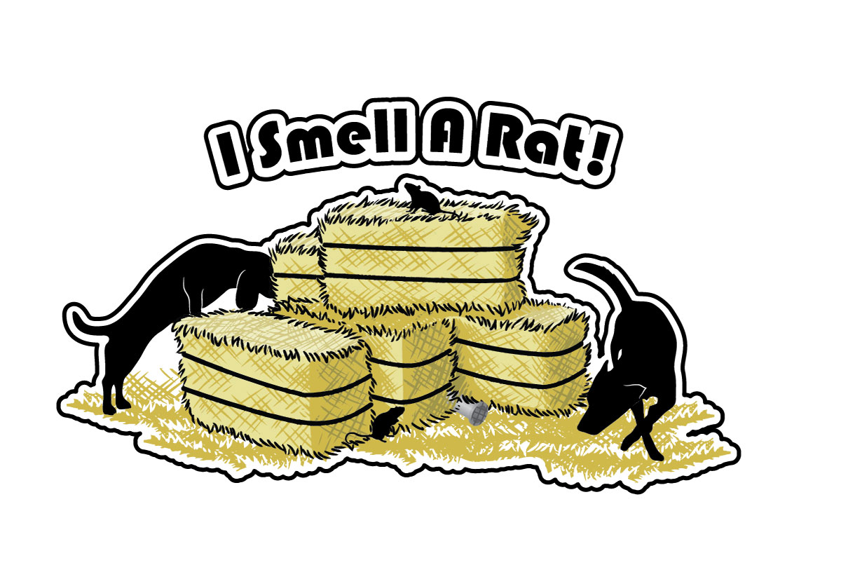
I Smell A Rat! Entry Form
Please fill out a new form for EACH dog if you have multiple entering the fun match.
Handler Name:_________________________________________________________________________
Dog Name: _____________________________________ Age: __________ Height at withers:_________
Have you ever tried a ratting sport before? Y / N
Have you ever been to our facility? Y / N
Does your dog require extra space (ie: not dog friendly)? Y/ N

 | Instinct | Beginner | Intermediate | Advanced | Expert
Hunter Level
Snakes and Ratters

Hunter Instinct: $5 per run
Beginner through Expert Hunter: $10 per run
Beginner through Expert Snakes and Ratters: $10 per run
Dogs may be listed for up to THREE runs per CLASS. An example of one CLASS is Snakes and Ratters, or Hunter Levels. If you have any questions, please do not hesitate to reach out to us.

Included in this entry form is our general waiver of liability. Your entry will not be accepted unless it is signed and dated accordingly. All entries must be accompanied with payment. If you do not submit payment with your entry form it will not be accepted. We will accept entries until we have filled the fun match and if there is still room once the entry date closes, we will consider day-of entries. Entries received before the opening date will not be accepted.

Hydeout Dog Training Liability Waiver
By signing this waiver, you are agreeing to and acknowledging that you understand the risks of yourself and/or your pets being on our property or within the business.
This is a dog daycare and training facility, and while we do our very best to ensure the safety of the pets in our care, as well as our clients, things can happen accidentally. The Hydeout Dog Training Center is not liable for any potential injuries that may incur to the client or pets while in our facility or on the business grounds.
Refund policy:
Full refunds are issued up to ONE WEEK prior to the event day. Beyond the one-week period leading up to the event, a refund will only be issued should a dog need to be pulled for a medical reason with a written note from your veterinarian.
In Relation to COVID-19:
You are also agreeing that:
- You have not displayed symptoms or tested positive for COVID
- You have not travelled outside of the province in the last 14 days
- You have not been in close contact with someone who has tested positive for COVID
- You are feeling healthy and not displaying symptoms of illness
- You are not breaking a self-isolation or quarantine order as described by the Saskatchewan Health Authority or Government of Saskatchewan
Printed Name: _________________________________________ Date: _____________________, 20__
Signature: ____________________________________________________________
Signature of Parent of Guardian if under the age of 16:
_________________________________________________________________________

